**LAB10 Secure coding Input validation**

**Class: Name: Truong Dang Truc Lam Student ID: B2111933**

| Resource | Hardware | Description |
| --- | --- | --- |
| OS | OS in class | Ubuntu |
| Client | PC in class | Python3 |
| Web  Server | Server in class |  |
| DB  Server | Share with Web Server  or different one |  |

1. **Choose one coding language (you can write in other languages)**

in java

<https://kodejava.org/how-do-i-validate-input-when-using-scanner/>

in JavaScript

<https://developer.mozilla.org/en-US/docs/Learn/HTML/Forms/Form_validation>

in-python e

<https://www.adventuresinmachinelearning.com/mastering-user-input-validation-in-python-best-practices-and-examples/>

<https://www.golinuxcloud.com/python-user-input-examples/>

in HTML

<https://developer.mozilla.org/en-US/docs/Learn/HTML/Forms/Form_validation>

I will choose Python

1. **Exercise one of following type**

**[Type 1] Process design**

**Select your language type**

**Survey, design your coding process and set-up environment**

**Explain your model**

**[Type 2] Coding**

**Python**

while True:

try:

upper_bound = 300.0

lower_bound = 0.0

height = float(input("Enter your height in centimeters: "))

if height < lower_bound or height > upper_bound:

print("Height must be between", lower_bound, "and", upper_bound)

continue

weight = float(input("Enter your weight in kilograms: "))

if weight < 0:

print("Weight cannot be negative.")

continue

bmi = weight / ((height / 100) ** 2)

if bmi < 18.5:

print("You are underweight.")

elif bmi >= 18.5 and bmi <= 24.9:

print("You are normal weight.")

elif bmi >= 25 and bmi <= 29.9:

print("You are overweight.")

else:

print("You are obese.")

break

except ValueError:

print("Invalid input. Please try again.")

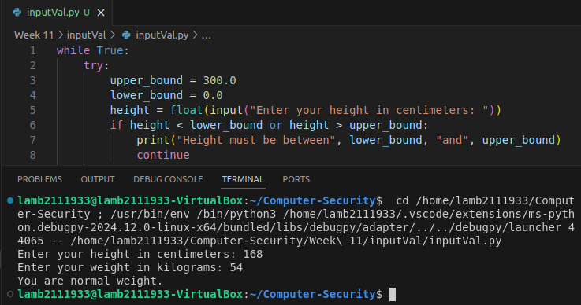

The provided Python code calculates a person's Body Mass Index (BMI) based on their height and weight:

* It first prompts the user to enter their height in centimeters and weight in kilograms.
* If either input is invalid (e.g., negative weight or height outside the specified range), an error message is displayed and the user is asked to re-enter the value.
* Once valid inputs are received, the BMI is calculated using the formula: BMI = weight / (height/100)^2.
* The calculated BMI is then compared to different ranges to determine if the person is underweight, normal weight, overweight, or obese.
* The corresponding message is printed to the console. The code continues to run in a loop until the user provides valid inputs and the BMI calculation is completed.